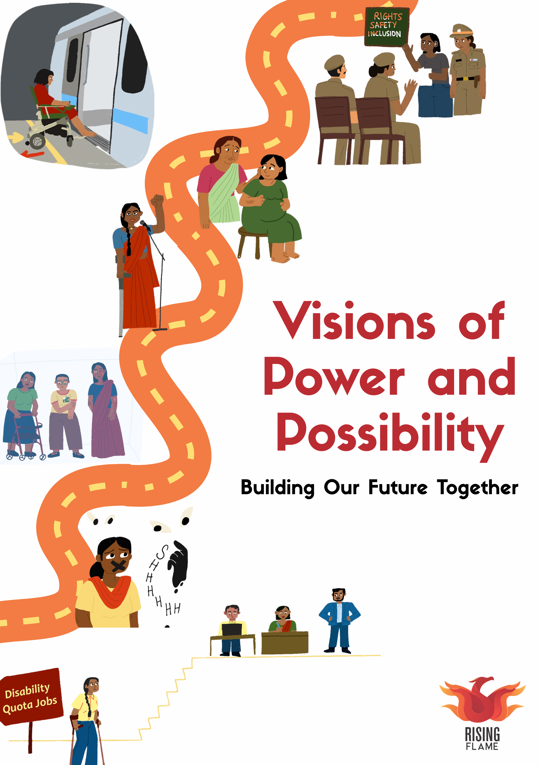

Credits & acknowledgments
Written by: Dr. Shikha Silliman Bhattacharjee and Gwyn D’mello
Review and editing by: Nidhi Ashok Goyal and Srinidhi Raghavan
Published by: Rising Flame
Booklet supported by: Rising Flame
Publication date: March 2026
Graphics designed by: Paus
Visions of Power and Possibility: Building Our Future Together was conceptualised and organised by Rising Flame at International Purple Fest 2025. Rising Flame was a key partner of International Purple Fest, the largest and first-of-its-kind global festival celebrating persons with disabilities organised by the Office of the State Commissioner of Persons with Disabilities, Government of Goa, Directorate of Social Welfare, Government of Goa and Department of Empowerment of Persons with Disabilities, Ministry of Social Justice and Empowerment, Government of India.

Introduction
This publication marks an important moment in the movement of women with disabilities in India: a moment to take stock of where we are today, and to build a collective vision for where we want to be five years from now. It emerges from a national dialogue with 40 women with disabilities, allies, and government representatives who came together not only to imagine the future, but to honestly assess the present—our strengths, our gains, our challenges, and the gaps that persist.
The roundtable took place within the International Purple Fest, a landmark global event promoting inclusion and accessibility, hosted by the Department for Empowerment of Persons with Disabilities and the Office of the State Commissioner for Persons with Disabilities, Government of Goa, in collaboration with the Ministry of Social Justice and Empowerment, Government of India, and United Nations India.
Within this larger festival, the dialogue in the form of half day event ‘Visions of Power and Possibility’ was created as a dedicated space to centre the specific experiences, leadership, and political priorities of women with disabilities, voices that are often marginalised within both disability rights and women’s rights spaces.
Designed as a participatory space, the session treated every woman in the room as an expert in her own lived experience and political context. Through introductions, small-group discussions, and plenary sharing, participants examined five interconnected issue areas: accessibility and inclusion; education; employment and livelihoods; health including mental health, maternal health and reproductive justice, and violence and access to justice. Together, they mapped the realities of the movement today—its creativity, resilience, diversity, and emerging sense of collective identity—alongside the barriers that continue to limit cross-disability solidarity, access to rights, safety, and opportunity.
From this grounding in the present, participants articulated a clear and ambitious vision for where we want to be in the next five years. This document captures that vision. It is intended for participants and their organisations, organisations of persons with disabilities, women’s rights and disability rights movements, funders, and government stakeholders across levels. As a visioning document, it offers both a snapshot of the current moment and a roadmap for the work ahead in five core areas as mentioned above.

Our present, our future
This document is organised to move from the present to the future.
- Section 1 maps where the movement of women with disabilities stands today — its strengths, challenges, and the realities across five core issue areas.
- Section 2 sets out the collective vision for change in the next five years in each of these issue areas.
- Section 3 outlines concrete pathways and recommendations for government, organisations of persons with disabilities, civil society, funders and institutions to act on.

The Movement Today

Strengths: What grounds the movement?
Participants named creativity, resilience, diversity and community as core strengths of the movement. One woman described this creativity as “the ways in which women resist, take up space and centre their voices,” even in systems that exclude them. Caregivers highlighted emotional resilience, noting how mothers of disabled children are “able to handle so much more than we put on” while continually finding opportunities for their children. Women affected by leprosy spoke of patience as a defining strength, saying “we always need to be patient as we hope for a better future.” Others emphasised how joining disabled people’s networks—such as blind collectives—has given them practical answers and solidarity that people don’t easily find on their own.
“We have started recognising women with disabilities as a movement… with that comes the spirit to dream, and with that spirit comes action.”
Most importantly, several participants said they are beginning to recognise themselves as a distinct movement of women with disabilities, not only as members of broader disability or women’s rights spaces. Another participant, who shared how her condition is still not formally recognised as a disability in India, summed it up: “the strength is that we are here. There is strength in numbers. There is strength in stories.”

Challenges: What holds the movement back?
Alongside these strengths, participants described several barriers that limit collective power. Many spoke about working in silos, focusing on their own disability or thematic area of work rather than organising as women with disabilities across issues. This approach can prevent shared analysis and joint advocacy and reflecting what several described as limited cross-disability understanding.
“We still talk in silos of our own disabilities… I talk about blindness more often than about myself as a woman with disability.”
A recurring concern was the gap between accessibility and real access. Participants noted that advocacy often focuses on ramps, screen-readers or sign language without addressing access to power, leadership roles, safety and decision-making. Limited visibility and lack of data on disabled women deepens this gap; for example, grassroots blind women are rarely represented in media or public forums.
Patriarchy and stigma continue to shape daily realities. Women discussed the pressure to mask their needs because of both gender expectations and stigma facing women with disabilities. These attitudes restrict mobility, safety, education and economic independence, and set the context for the challenges explored across all five issue areas.

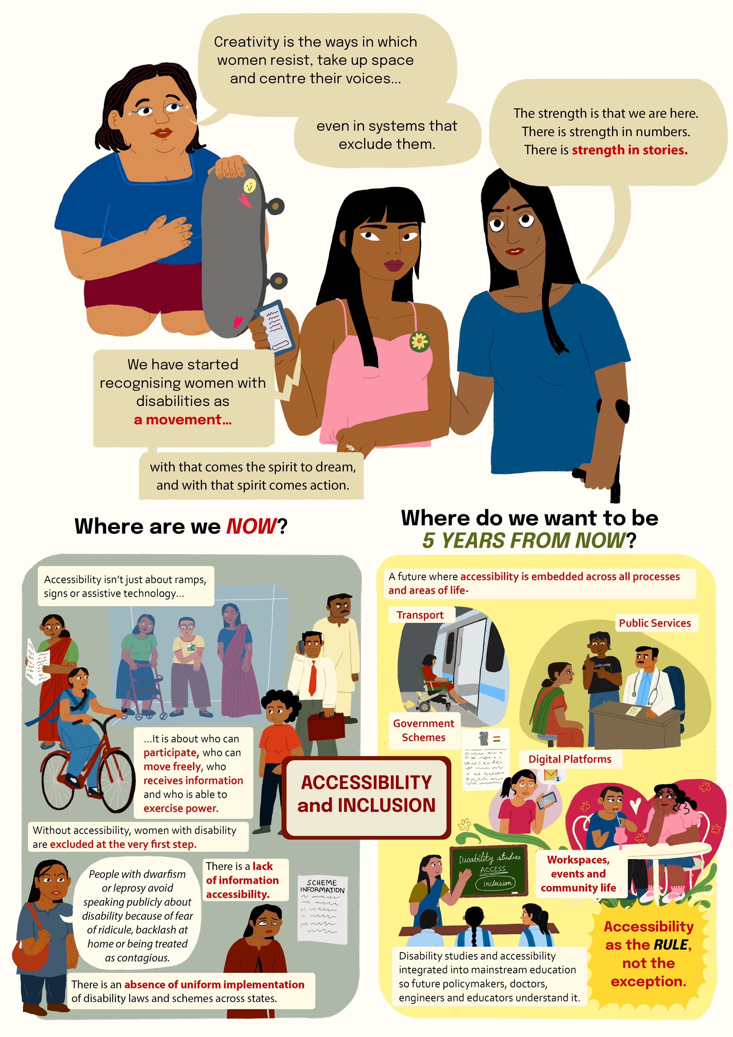
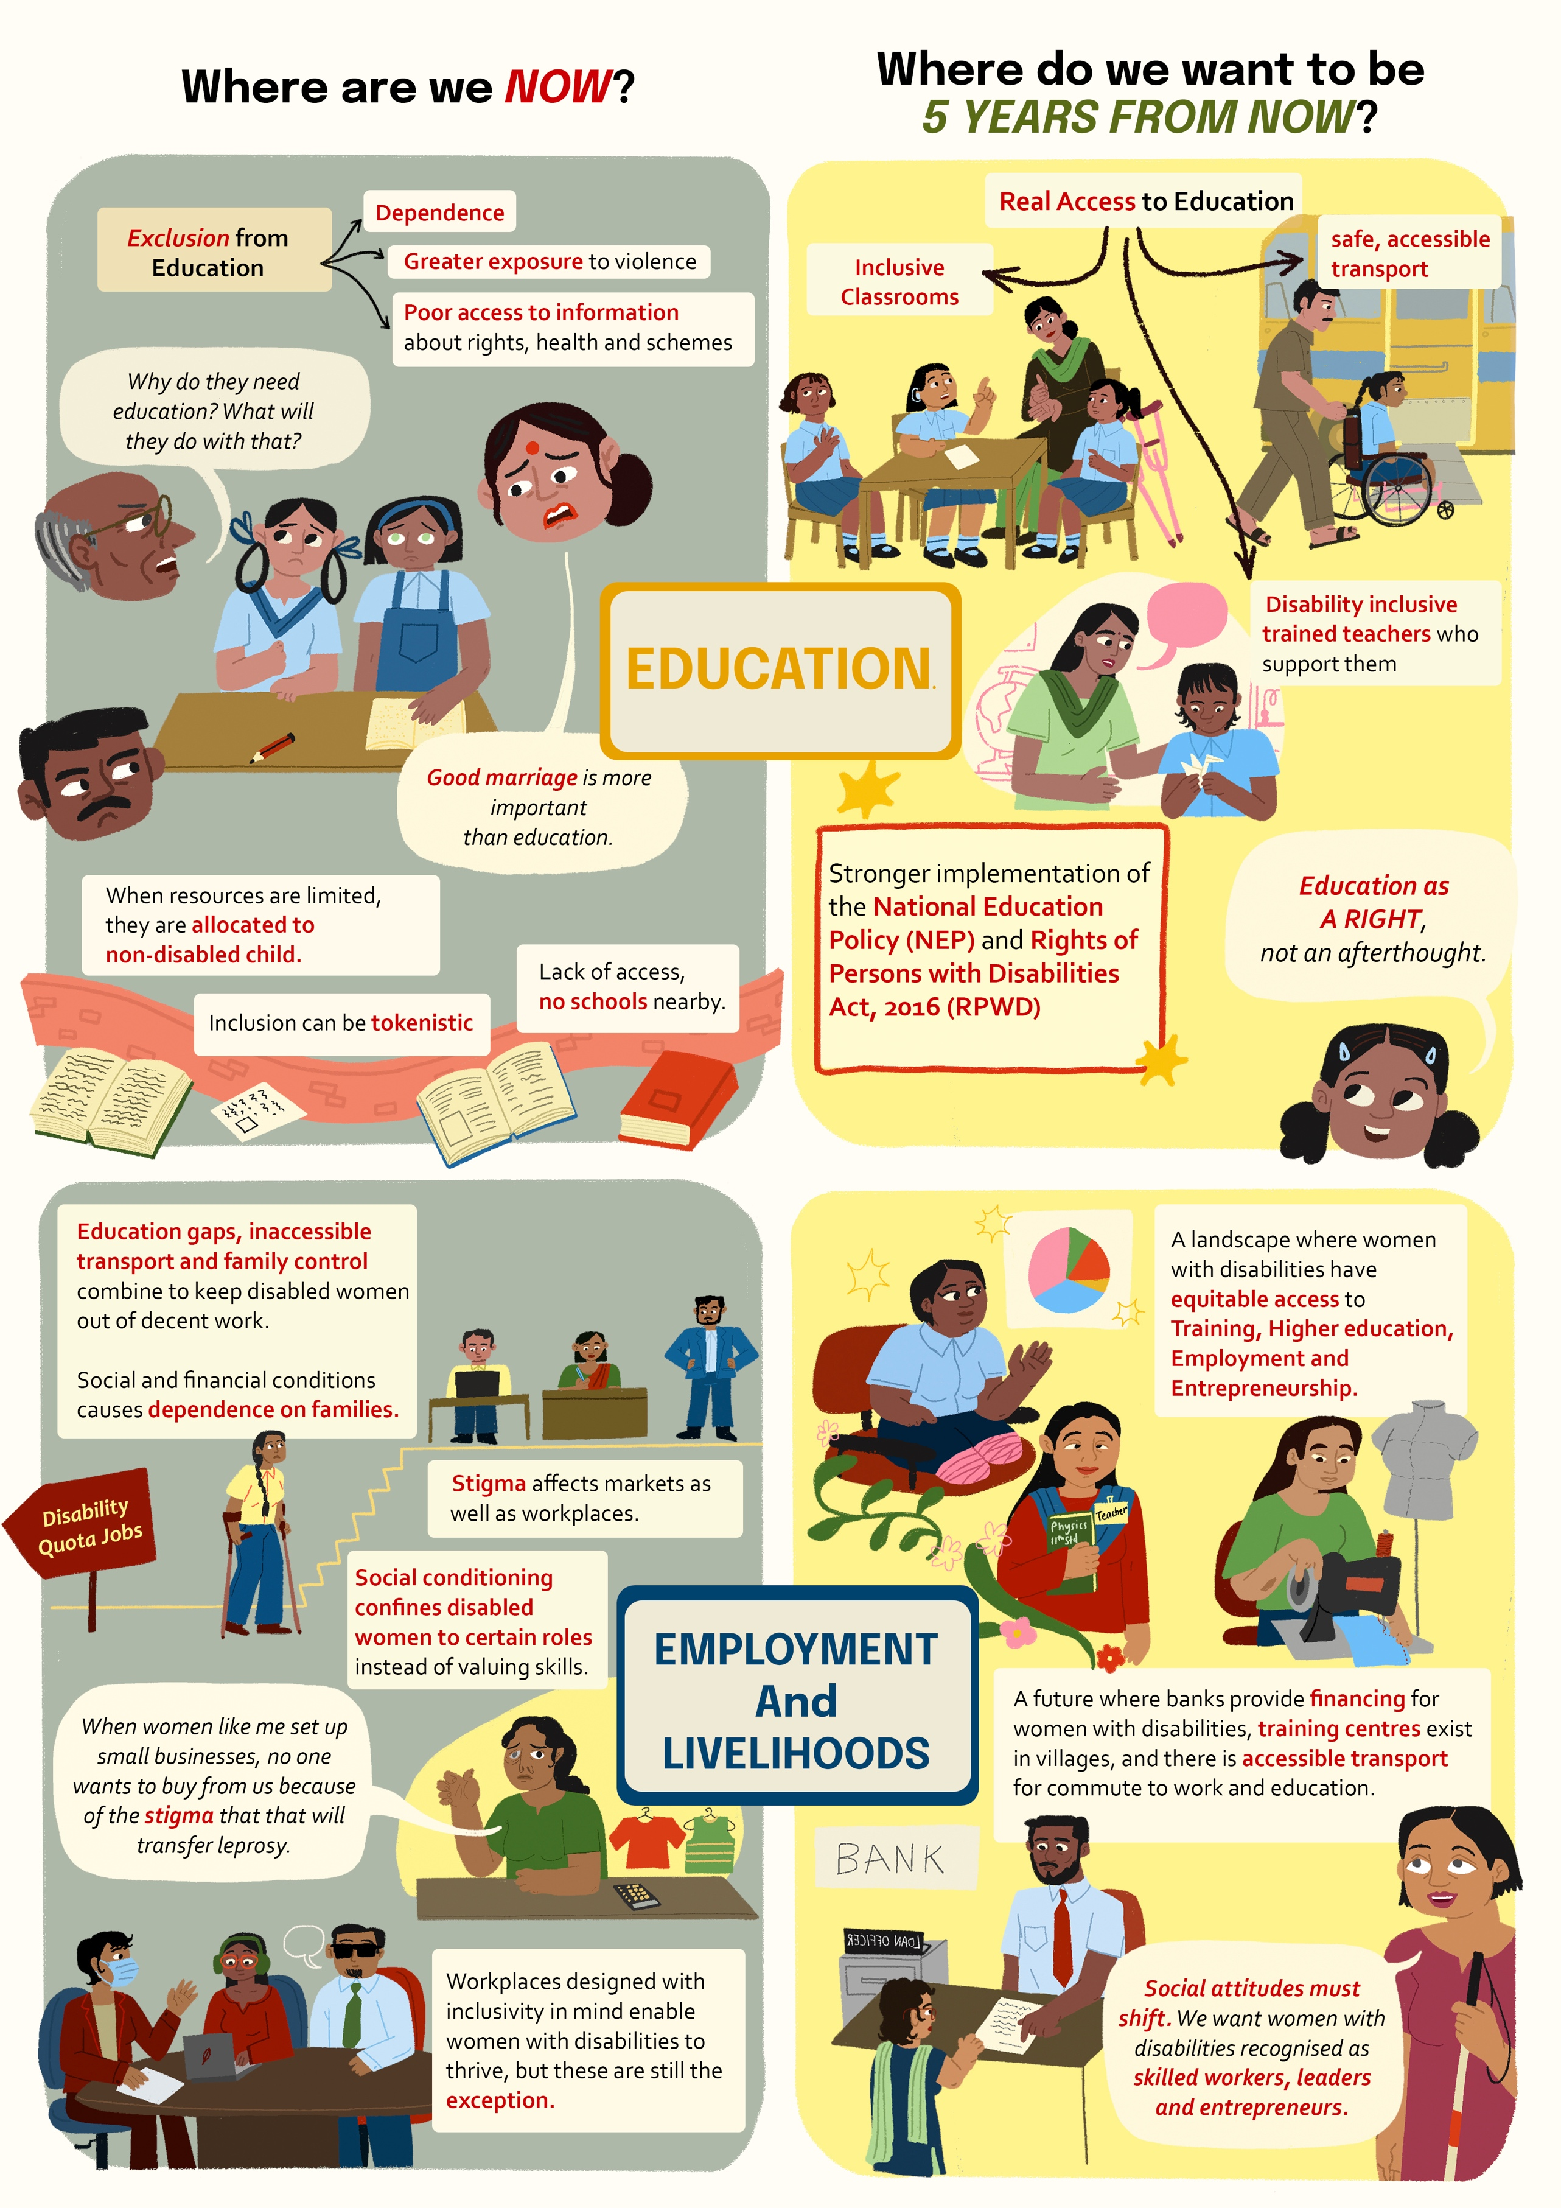
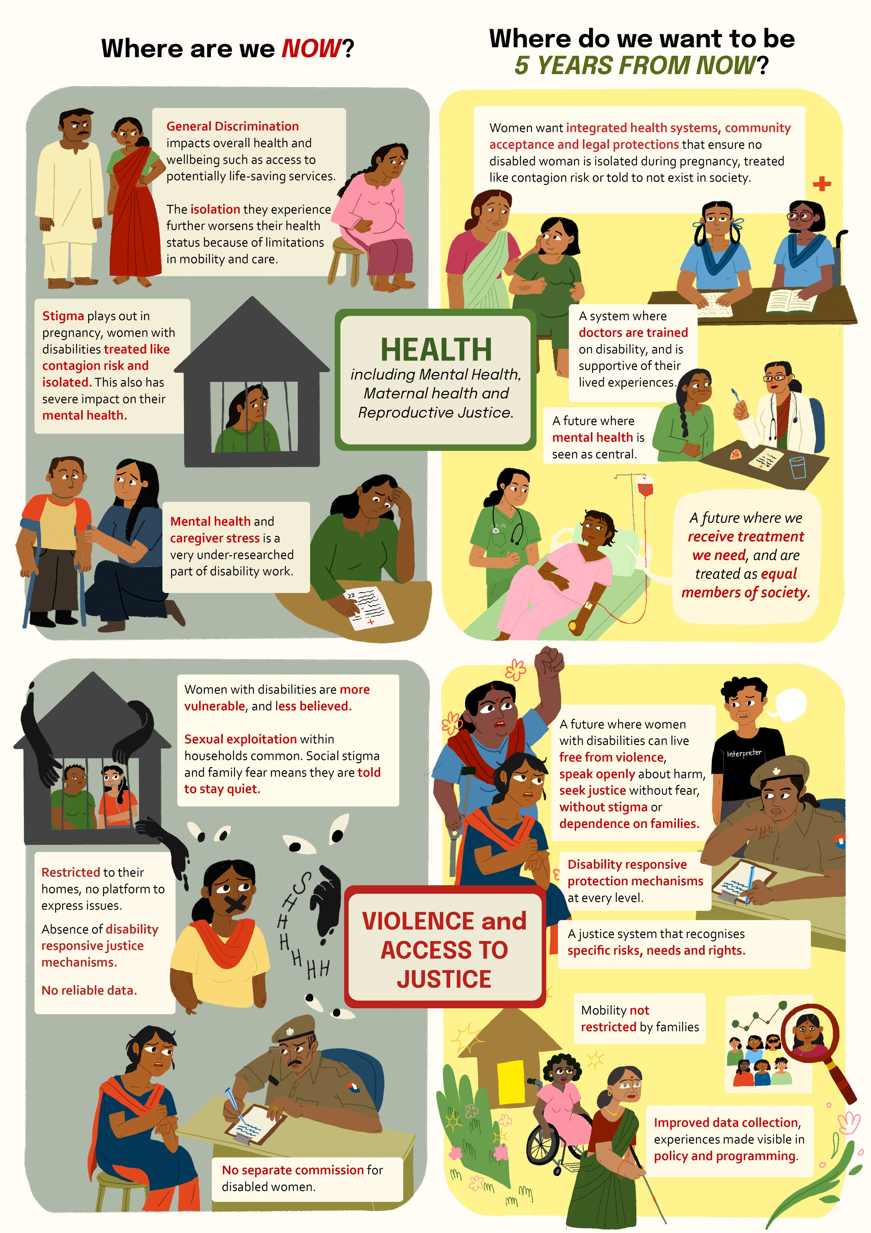

Where are we now? Key issue areas

Accessibility and inclusion
Participants emphasised that accessibility is not only about ramps, signs, or assistive technologies—it is about who can participate, who can move freely, who receives information, and who is able to exercise power. In practice, accessibility determines whether women with disabilities can reach school, apply for work, travel safely, participate in public events, or even speak openly about their disability. Without accessible systems, many women are excluded at the very first step.
Social attitudes create additional layers of exclusion. Women described how disability continues to be framed through stigma or charity rather than rights. Others shared that people with dwarfism or leprosy often avoid speaking publicly about disability because of fear of ridicule, backlash at home, or being treated as contagious.
“People don’t want to speak out in rural areas because of many reasons. Around 500 people with dwarfism live in my community today, and they don’t want to talk about their disability, saying their parents will be upset. Or they’ll face more jokes in their hometown. People only become more outspoken when you give them an accessible platform to do it.”
Women described the persistent structural barriers that shape their daily lives. Several spoke about the absence of uniform implementation of disability laws and schemes across states: a scheme available in one state is not there in another which impacts people’s access to entitlements.
Others pointed out that public infrastructure rarely takes people with disabilities into account. One woman noted that there is “no proper public transport, let alone provisions for people with disabilities,” making movement across the city difficult even during a disability-focused event.
Participants also highlighted the role of information accessibility. Many people with disabilities never learn about rights, schemes or protections because information is not available in accessible formats or in languages they can use. One woman asked pointedly: “If there’s even a small rule related to disability, does that reach every disabled person?” The answer, repeatedly, was no.

Education
Participants identified education as a missing foundation. Participants linked patterns of educational exclusion to later vulnerabilities: dependence, greater exposure to violence, and poor access to information about rights, health and schemes.
“We need basic access to school education, which we currently don’t have especially in rural areas.”
Attitudinal barriers were stark. Women described hearing questions like “why do they need education, what will they do with it?” When families have limited resources, “they will be allocated to the non-disabled child,” leaving girls with disabilities further behind. Some participants had not completed school because there were no schools nearby, or schools that only went up to a certain grade. Gender and disability, moreover, combine to deny education. In Bihar, for example, there are four government schools for blind boys and none for blind girls.
“We are also deprived of completing education because the parents are mainly labourers and they are busy with working in the fields and they don't have the time to go and drop the children and bring them back. So, education is hampered.”
Even when children are enrolled, inclusion can be tokenistic. Participants explained that children with disabilities are admitted, “their name is on the roll, but they get no support, they just sit in class,” and sometimes parents stop sending them but “the kids still get promoted up through classes… just for the sake of it.” They also spoke about how they often heard that “good marriage is more important than education.”

Employment and livelihoods
Women described how education gaps, inaccessible transport and family control combine to keep disabled women out of decent work. Social and financial conditions mean many are dependent on families. They also find that there is no guidance for studying or even related to their career.
“There is also a poor confidence in them to be able to come out, especially because the other systems are not supportive of them, whether family or society.”
Stigma affects markets as well as workplaces. Women affected by leprosy reported that when they set up small businesses, “no one wants to buy things from them, because of the stigma that that will transfer the leprosy.” Participants criticised social conditioning that confines disabled people to certain roles — “you’ll get a certain kind of job, within a certain quota”— instead of valuing skills.
At the same time, one of the corporate employees in the room offered a positive example: “They treat us equally. With or without disability.” When workplaces and initiatives are designed with inclusion in mind, women with disabilities can and do thrive — but such spaces are still the exception.

Health including mental health, maternal health and reproductive justice
Women with disabilities spoke about the general discrimination they face in society which impacts their overall health and well-being such as access to services which maybe lifesaving. The isolation that women with disabilities encounter also results in their health status becoming worse because of the limitations in mobility and care.
Health and reproductive justice surfaced as areas of acute concern. Women described how stigma plays out in pregnancy. A participant recounted how a woman with leprosy was told by her mother-in-law to leave the house while pregnant because she feared the disease would spread to the baby and the family. It was only because her husband supported her, took her to the hospital and insisted on treatment that both she and the child are now doing okay.
“They told me to leave the house during pregnancy… they feared I would spread leprosy to the baby and the family. So, there was a lot of misunderstanding about it and it was very difficult for me in that period but it was my husband who supported me who took me to the hospital to get me treated and got me treatment for the same. And it was because of his support that I was able to both access the treatment and both me and the child are now doing okay.”
Many women spoke about being confined to their homes with severe consequences for mental well-being. Women affected by leprosy described how families and communities respond to their diagnosis with isolation: “you should not send her to school; you should not let her meet her friends.” In some villages, women with disabilities are asked not to participate in society at all and sometimes asked to leave the village.
Mental health and caregiver stress were also highlighted. Participants described mental health of mothers and caregivers as “a very under-researched part” of disability work.

Violence and access to justice
Violence and barriers to accessing justice were identified as central concerns. Participants explained that being women with disabilities makes them more vulnerable and less believed. Sexual exploitation within extended households was described as common, especially where women are dependent and considered submissive. Women with disabilities may be restricted to their homes and have no platform to express their issues and concerns. Social stigma and family fears mean that when women try to report abuse, they are told to stay quiet. Poverty intensifies these risks.
“Women with disabilities are kind of suppressed and asked to keep quiet, not make a noise about anything. Parents' also hesitate as they have a fear of society, especially being accepted in society. And they have that fear that if they allow the woman with disabilities to speak up, then tomorrow there will be problems like she will not get a suitable match.”
Women also highlighted the absence of disability-responsive justice mechanisms. “There’s no separate commission for disabled women,” women explained. “There is no reliable data on disabled women, and no government support to identify the problems of disabled women at grassroots levels.” As a result, disabled women’s rights to bodily autonomy, safety and justice are routinely denied, often by the very families and systems meant to protect them. They also spoke about how fear of violence impacted their mobility, their education and employment.
“Poverty and disability are a lethal combination. Families may lack money even for basic needs, let alone legal recourse.”

In the next five years

Accessibility and inclusion: Building systems that allow women to participate, lead and be heard
Participants imagined a future where accessibility is embedded across all processes and areas of life —transport, public services, government schemes, digital platforms, workplaces, events and community life. This means uniform implementation of disability laws across states, accessible information across languages and formats, and infrastructure designed with women with disabilities in mind.
“We need mandatory norms, so accessibility is the rule, not the exception.”
Participants also called for disability studies and accessibility to be integrated into mainstream school and university curricula—so future policymakers, doctors, engineers and educators understand disability from the start.

Education: Ensuring every girl with a disability learns and thrives
Participants want girls with disabilities to have real access to schooling. This includes safe transport, inclusive classrooms, and teachers trained to support them. Women envisioned a future where no girl is denied admission, where rural areas have functioning local schools, and where education is a right, not an afterthought. As one woman explained: “everybody needs education… livelihood and control over our own lives must come first.”
“We want basic school education to be accessible to everybody—and good education, not just presence, even active participation.”
Participants called for stronger implementation of the Rights of Persons with Disabilities Act, 2016 (RPWD) and National Education Policy (NEP), disability-inclusive teacher training, and school systems that ensure disabled girls are not pushed out because families have other priorities or because transport is unavailable. in the next five years education must provide the foundation for independence, leadership and safety.

Employment and livelihoods: creating pathways to independence, confidence and leadership
In the next five years, participants wanted a landscape where women with disabilities have equitable access to training, higher education, employment and entrepreneurship. They described a future in which banks provide financing for women with disabilities, training centres exist within villages, and accessible transport makes it possible to commute to work or education.
“Women with disabilities should be independent, confident, and respected—able to move in society and run their own businesses.”
Participants were clear that social attitudes must shift: women with disabilities must be recognised as skilled workers, leaders and entrepreneurs—not limited to quota jobs or dismissed as incapable. They pointed to inclusive workspaces where “they treat us equally, with or without disability” as proof of what is possible.

Health including mental health, maternal health and reproductive justice: Building and nurturing health equity
Women want integrated health systems, community acceptance, and legal protections that ensure no disabled woman is told to leave the house or not exist in society.
“We want health care without discrimination—where women with disabilities are seen as full human beings.”
Participants envisioned a future where women with disabilities are not isolated during pregnancy, not barred from school or social life, and not treated as burdens or contagion risks. They want a healthcare system where doctors are trained on disability, where women are treated with respect, and where reproductive and maternal health are recognised as fundamental rights. They also asked for the systems to be supportive of them and their lived experiences. They also felt that women with disabilities should be able to receive the treatment that they need for their conditions and that they are seen as equal participants in society.
Mental health must also be central—both for women with disabilities and for caregivers, whose emotional labour remains a very under-researched part of disability work.

Violence and access to justice: Safety, autonomy, and accountability
In the next five years, participants want a future where women with disabilities can live free from violence, speak openly about harm, and seek justice without fear, stigma or dependence on families. They described a justice system that must shift from one that ignores disabled women to one that recognises their specific risks, communication needs, and rights.
“We want a future where women with disabilities can come out of their homes, speak freely, and have justice systems that actually listen.”
Women envisioned a future where mobility is not restricted by families “for fear of society,” where girls are not told to stay quiet to protect marriage prospects, and where sexual exploitation within extended households is neither normalised nor hidden. Ensuring safety requires addressing these social norms alongside structural barriers.
Participants called for disability-responsive protection mechanisms at every level. This includes establishing a dedicated body to address violence against women with disabilities, sensitising police and judiciary, and building reporting systems that disabled women can access independently—online, in person, or through trusted community groups.
Data collection must improve dramatically. Without reliable information on the scale and forms of violence against women with disabilities, their experiences remain invisible in policy and programming. Participants urged government agencies to track violence against women with disabilities across districts and ensure this data drives resource allocation and interventions.
Finally, participants stressed that safety must not depend on wealth. A rights-based justice system must therefore include free legal aid, accessible counselling, community-level awareness, and safe spaces where disabled women can speak without fear of retaliation.

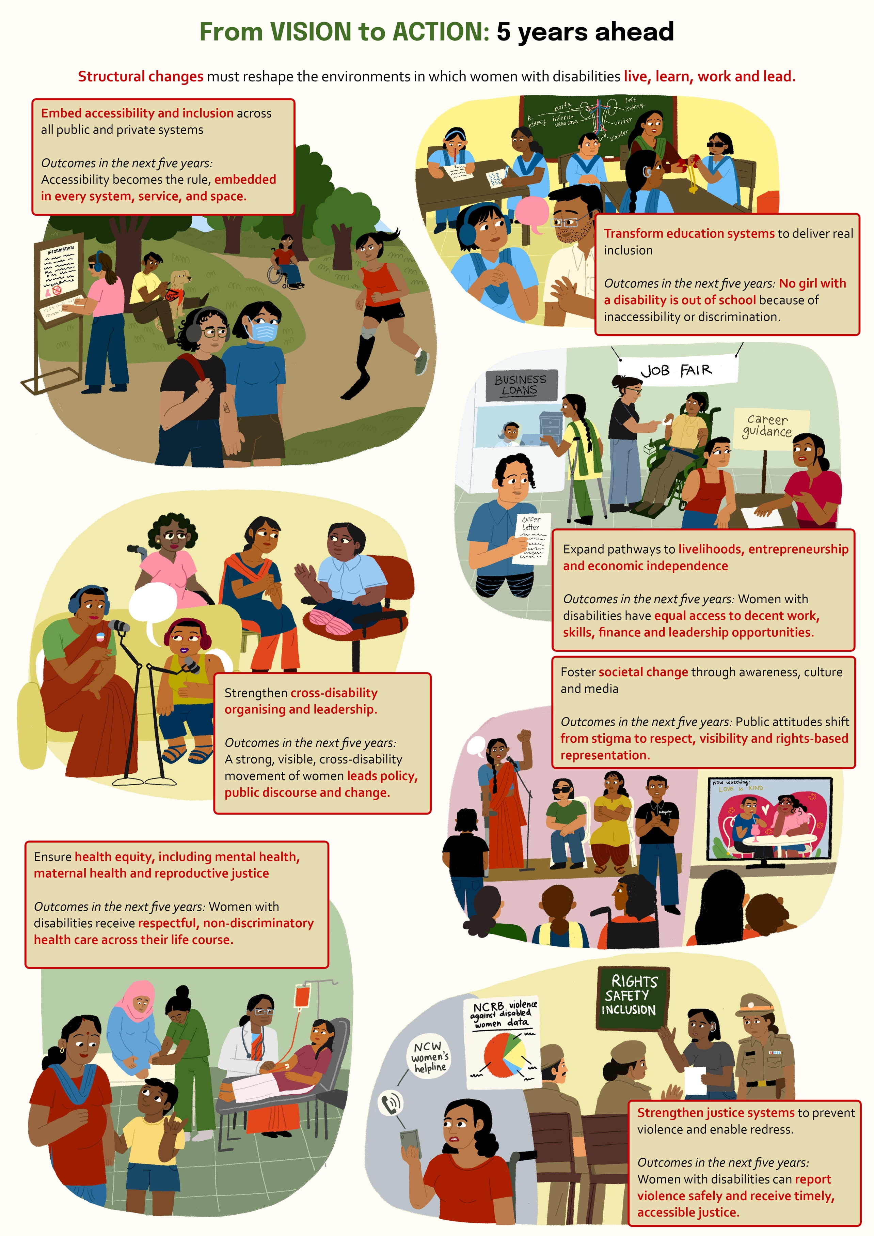

From Vision to Action: 5 years ahead
Across the roundtable, women emphasised that moving from vision to implementation will require coordinated action by the movement, government agencies, educators, funders, OPDs, and civil society. Participants were clear that progress cannot rely only on individual resilience; structural changes must reshape the environments in which women with disabilities live, learn, work and lead. The following pathways summarise the concrete actions needed across sectors to bring the vision to life.

Embed accessibility and inclusion across all public and private systems

Outcomes in the next five years: Accessibility becomes the rule, embedded in every system, service, and space.
- Mandate uniform implementation of disability rights and schemes across states and create accountability mechanisms for compliance.
- Ensure information on rights, entitlements and services is accessible across formats, languages and digital platforms.
- Require accessibility standards in public transport, civic infrastructure, workplaces, government offices, events and digital environments.
- Integrate disability studies and accessibility into school and university curricula to shift norms among future policymakers, engineers, doctors and educators.

Transform education systems to deliver real inclusion

Outcomes in the next five years: No girl with a disability is out of school because of inaccessibility or discrimination.
- Ensure implementation of RPWD and NEP provisions that guarantee free, accessible education for all children with disabilities.
- Expand disability-inclusive teacher training and require disability knowledge across mainstream training programmes.
- Provide safe, accessible transport for children and especially girls with disabilities—especially in rural areas so education is not contingent on families’ ability to escort them.
- Advance meaningful support systems: resource rooms, trained staff, assistive devices, and monitoring of learning outcomes.

Expand pathways to livelihoods, entrepreneurship and economic independence

Outcomes in the next five years: Women with disabilities have equal access to decent work, skills, finance and leadership opportunities.
- Increase access to local, accessible training centres, higher education pathways and career guidance tailored to women with disabilities.
- Create dedicated financing channels—such as bank loans, microfinance and entrepreneurship schemes—for women with disabilities.
- Strengthen workplace inclusion by promoting reasonable accommodations, anti-discrimination policies, and affirmative hiring across sectors.
- Support community-based livelihood models and challenge market stigma, especially for women affected by leprosy or other marginalised disabilities.

Ensure health equity, including mental health, maternal health and reproductive justice

Outcomes in the next five years: Women with disabilities receive respectful, non-discriminatory health care across their life course.
- Mandate disability-inclusive training for healthcare workers at all levels, from primary health centres to hospitals.
- Guarantee non-discriminatory access to reproductive and maternal healthcare, including information, informed consent, and respectful treatment.
- Recognise and resource the mental health needs of women with disabilities and caregivers, including counselling, peer-support groups and community-based services.
- Build systems that prevent isolation—ensuring no woman is told to remain inside, hide her diagnosis, or leave her community.

Strengthen justice systems to prevent violence and enable redress

Outcomes in the next five years: Women with disabilities can report violence safely and receive timely, accessible justice.
- Train police, judiciary and protection officers on disability rights and communication needs.
- Ensure safe reporting options—online, telephonic, and community-based—that women with disabilities can use without family mediation.
- Establish data systems to record violence against women with disabilities, enabling visibility, research, and policy response.

Foster societal change through awareness, culture and media

Outcomes in the next five years: Public attitudes shift from stigma to respect, visibility and rights-based representation.
- Promote accurate, rights-based representation of women with disability in media, including grassroots voices.
- Encourage community dialogues that challenge stigma, ableism and patriarchal norms.
- Support disability-inclusive curricula and experiential learning in schools to normalise disability from early ages.
- Use cultural platforms—festivals, social media, arts and storytelling—to shift public attitudes from charity to respect.

Strengthen cross-disability organising and leadership

Outcomes in the next five years: A strong, visible, cross-disability movement of women leads policy, public discourse and change.
- Build regular cross-disability spaces for women to learn from one another, share strategies, and deepen solidarity.
- Support leadership development programmes that centre women with disabilities—including young women, queer and trans disabled people, and caregivers.
- Document, archive and amplify stories from grassroots women with disabilities to strengthen collective identity and disrupt invisibility.

